
LESSON NOTE | DETAILED EXPLANATORY NOTES
BIOENERGY
THE MOSES EXPERIMENT ('BURNING BUSH')

GRADE 12 - BIOLOGY
■ ■ ■

What is the 'Burning Bush'?
The Moses Experiment, or 'Burning Bush', is a striking demonstration in which a plant appears to burst into flame yet is not burned up. It takes its name from the biblical story of Moses, who saw a bush that burned but was not consumed. The real science behind it is simple: some plants release flammable volatile oils into the air, and it is this vapour - not the plant itself - that briefly catches fire. The classic example is the gas plant (Dictamnus albus), also nicknamed the 'burning bush'.
This demonstration is a memorable way to link plant biochemistry to bioenergy: it shows that plants make and store energy-rich, combustible compounds. This lesson explains what causes the effect, why the plant survives, and how it connects to the wider study of biomass, biofuels and plant oils - including in Papua New Guinea.
Why the Burning Bush Matters
- It shows that plants make energy-rich, flammable compounds (volatile oils).
- It links plant chemistry to biofuels and bioenergy.
- It is a memorable, safe demonstration of stored chemical energy.
- It helps explain why some plants and forests are highly flammable.
The Moses Experiment (Burning Bush)
Key Learning Outcomes
By the end of this lesson, students should be able to:
- Describe the 'burning bush' effect and what actually burns.
- Explain how plants produce and release volatile oils.
- Explain why the plant is not harmed when the vapour ignites.
- Link the effect to the idea that plants store energy in carbon compounds.
- Connect this to biofuels and bioenergy, including in Papua New Guinea.
What Actually Happens
On a hot, still day, certain plants release volatile oils - light, easily evaporated compounds - from their leaves and flowers. These oils evaporate into the warm air around the plant, forming an invisible cloud of flammable vapour. If a small flame or spark is brought near, the vapour ignites in a quick flash of fire. Because the vapour burns so fast and the plant's tissues are full of water, the flame passes before the plant can be damaged - so the leaves stay green and unburnt, exactly like the bush Moses is said to have seen.
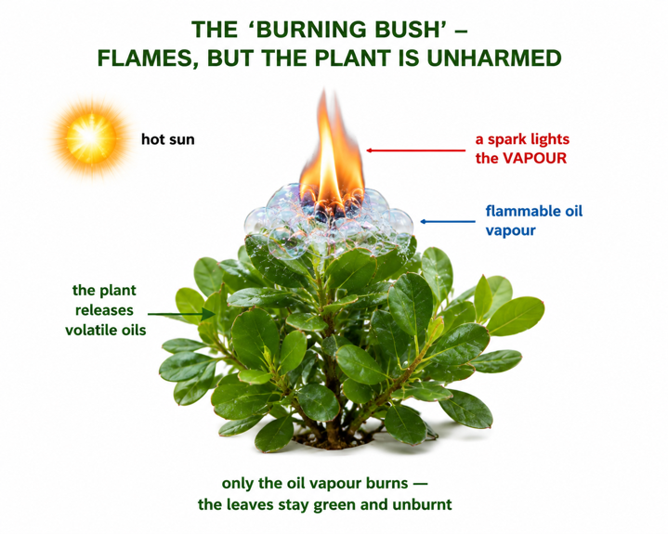
Figure 1: The 'burning bush' - the flammable oil vapour around the plant ignites, but the plant itself is unharmed.
Terminologies and Concepts
Useful terms for this topic:
- Volatile oil: a plant oil that evaporates easily into the air.
- Essential oils / terpenes: aromatic, flammable compounds many plants produce.
- Volatile organic compounds (VOCs): carbon compounds that readily become vapour.
- Combustion: burning - a rapid reaction of a fuel with oxygen, releasing energy.
- Flammable: easily set on fire.
- Gas plant (Dictamnus albus): the plant nicknamed 'burning bush' for this effect.
Why the Bush Appears to Burn - The Science
The effect depends on three things happening together. First, heat from the sun warms the plant and its oils. Second, the plant's volatile oils evaporate, surrounding it with a flammable vapour. Third, a spark or flame ignites that vapour, giving a brief flash of fire. The key point is that it is the vapour that burns, not the plant - the flame is fast and the leaves are protected by their water content, so the plant survives.
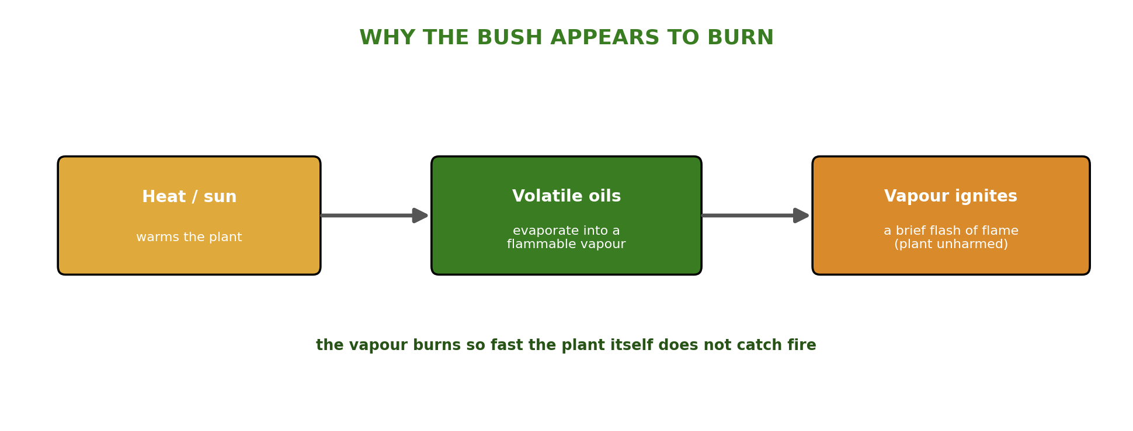
Figure 2: Heat releases the plant's volatile oils as vapour, which ignites in a brief flash while the plant stays unharmed.
Note: this activity involves an open flame and flammable vapour, so it should only ever be done as a controlled teacher demonstration, outdoors and away from anything else that could catch fire.
The Link to Stored Energy and Bioenergy
Why do these oils burn at all? Because they are energy-rich carbon compounds. During photosynthesis, plants capture the Sun's energy and build it into sugars, and then into oils and other molecules. The energy stored in those chemical bonds is released as heat and light when the oil vapour combusts - which is exactly why plant materials make good fuels. The 'burning bush' is really a vivid demonstration of the same principle behind biomass, biofuels and biodiesel: plants are stores of solar energy in chemical form.
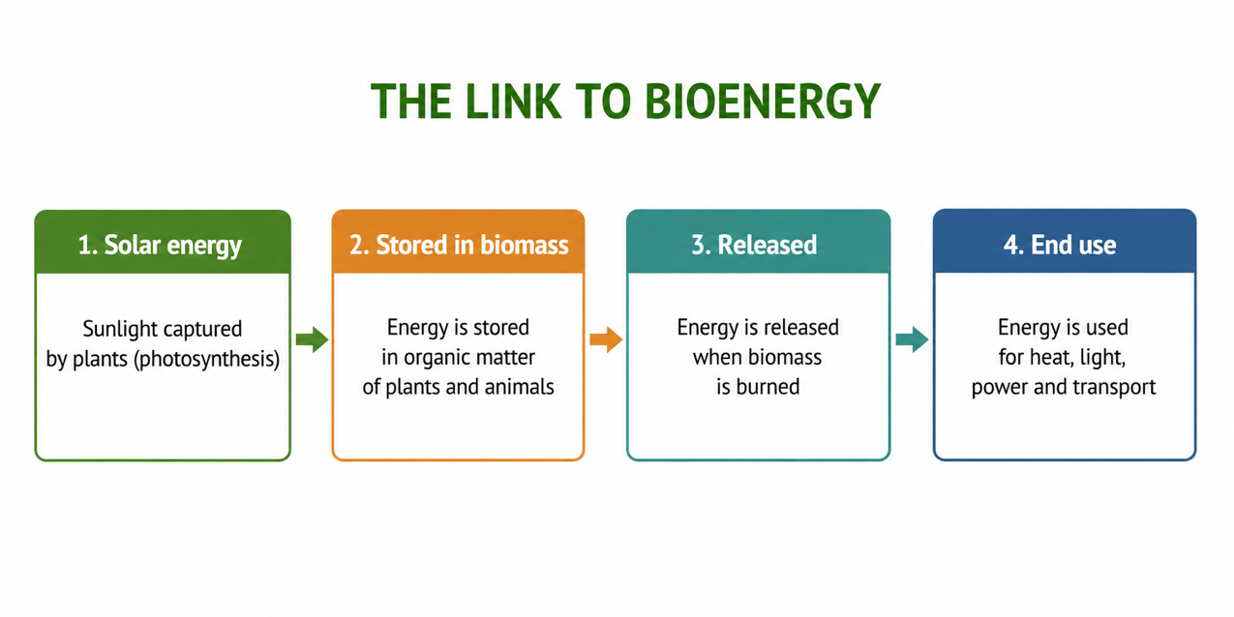
Figure 3: The burning bush links to bioenergy - plants store energy in flammable oils that can be used as fuel.
Real Examples of Flammable Plants
Many plants beyond the gas plant produce flammable oils. Eucalyptus (gum) trees are famous for their oil-rich leaves, whose vapours can make bushfires burn fiercely. Pine trees give off flammable resin and terpenes; citrus peel oils will flare in a flame; and many herbs and spices owe their scent to volatile oils. In every case the plant is storing energy-rich compounds that happen to be flammable - a natural link between everyday plants and the idea of bioenergy.
Advantages and Cautions of the Demonstration
Value as a demonstration | Cautions
Vividly shows stored chemical energy in plants | Uses an open flame and flammable vapour
Links plant biology to biofuels and combustion | Must be a controlled teacher demonstration only
Memorable and engaging for students | Should be done outdoors, away from other fuel
Connects science to a well-known story | Never attempt near dry vegetation or indoors
Worked Example - Burning a Plant Oil
When a plant's volatile oil (a hydrocarbon-rich compound) burns in air, it reacts with oxygen:
Plant oil (hydrocarbon) + O₂ → CO₂ + H₂O + energy
This is a combustion reaction: the energy stored by photosynthesis is released as heat and light (the flash of flame). It is the same type of reaction as burning firewood or biodiesel — showing that the 'burning bush' and modern biofuels rely on exactly the same chemistry of releasing stored solar energy.
Why This Matters
- Stored energy - it shows plants hold the Sun's energy in chemical bonds.
- Bioenergy - the same chemistry underlies biomass, biofuels and biodiesel.
- Fire science - it explains why oil-rich plants and forests burn so readily.
- Engagement - a memorable link between a famous story and real biology.
PNG Context Example
Papua New Guinea's forests are rich in oil-bearing and aromatic plants - eucalyptus and gum trees, pines, tea tree, citrus and many scented herbs - all of which store flammable volatile oils. This helps explain how bush and grassland fires can spread quickly in the dry season, and it points to a resource: plant oils that can be pressed and used as fuels or biodiesel (as in the Biomass & Biofuels lesson). Studying the 'burning bush' effect gives PNG students a memorable, locally relevant way to understand stored chemical energy and its link to bioenergy.
References & Related Documents
Source Documents
- STEM Biology Syllabus - Grade 12. Thema: Energy; Module 12.1 Bioenergy (The Moses Experiment / Burning Bush demonstration). Department of Education, PNG.
- Biology Standards-Based Syllabus, Grades 11 & 12 (PNG SBC 2020) - Strand 2: Life; examine photosynthesis and the storage and release of chemical energy in living systems.
Further Reading & References
- OpenStax Biology - Photosynthesis; Energy Storage in Organic Molecules. https://openstax.org/books/biology
- Britannica - Dictamnus (gas plant / burning bush) and plant volatile oils. https://www.britannica.com

